Machine Learning CRN – 22037

Chandrakanth Bikumandla 700726229

Github Link - <https://github.com/chandrakanth9933/ML-Assignment-2>

Question 1

**Use a python code to display the following star pattern using the for loop**

*

**

***

****

*****

****

***

**

**Output**

**2. Use looping to output the elements from a provided list present at odd indexes.**

**my_list = [10, 20, 30, 40, 50, 60, 70, 80, 90, 100]**

**Output**

**3. Write a code that appends the type of elements from a given list.**

**Input**

**x = [23, ‘Python’, 23.98]**

**Expected output**

[23, 'Python', 23.98]

**[<class 'int'>, <class 'str'>, <class 'float'>]**

**Output :**

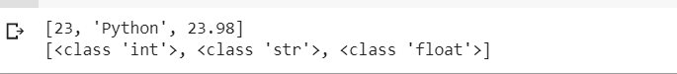

**4. Write a function that takes a list and returns a new list with unique items of the first list.**

**Sample List: [1,2,3,3,3,3,4,5]**

**Unique List: [1, 2, 3, 4, 5]**

**5. Write a function that accepts a string and calculate the number of upper-case letters and lower-case letters.**

**Input String: 'The quick Brow Fox'**

**Expected Output:**

**No. of Upper-case characters: 3**

**No. of Lower-case Characters: 12**

**s**

